Try and catch:

**Case 1--Code:**

package tryandcatch;

public class Tryandcatch

{

public static void main(String args[])

{

int[] array = new int[3];

try

{

array[9] = 3;

}

catch (ArrayIndexOutOfBoundsException e)

{

System.out.println("Array index is out of bound\n");

}

finally

{

System.out.println("The array is of size " + array.length);

}

}

}

**Output:**

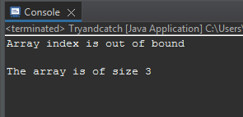

**Case 2--Code:**

package tryandcatch;

public class Tryandcatch

{

public static void main(String args[])

{

int[] array = new int[3];

try

{

array[1] = 3;

}

catch (ArrayIndexOutOfBoundsException e)

{

System.out.println("Array index is out of bound\n");

}

finally

{

System.out.println("The array is of size " + array.length);

}

}

}

**Output:**

